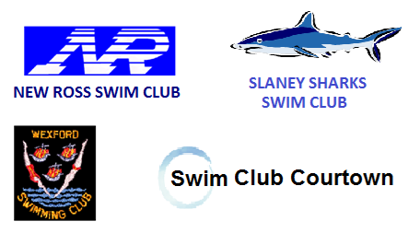2014 – 2015

**County Wexford**

**Round Robin Galas**

|  |  |
| --- | --- |
| **Date** | March 22nd 2015 |
|  |  |
| **Time** | 8:30am Warm up 9:00am Start |
|  |  |
| **Venue** | Wexford swimming pool, Co. Wexford |
|  |  |
| **Entries to** | Thelma by text or email |
|  |  |
| **Closing Date** | Tuesday 17thMarch |
|  |  |
| **Entry Fees** | €10 per swimmer |
| Relays - no charge |
|  |  |
|  |  |
| **Relays** | As relays are only for fun, teams can be made up of any mix of boys & girls. Also swimmers can swim up for relays. The aim is to allow most if not all swimmers a chance to swim a relay. |
|  |  |
| **Points** | 4 points will be awarded to the fastest club in the individual IM event, 3 points to the next fastest club etc. Points based on each clubs fastest swimmer in that event |
|  |  |

**Event Order (may change on the day)**

|  |  |  |  |  |  |  |  |  |  |  |
| --- | --- | --- | --- | --- | --- | --- | --- | --- | --- | --- |
| 1 |  | 8 & U | 100m | IM |  | 9 | Mixed | 10 & U | 100m | Medley Relay |
| 2 |  | 9 to 11 | 100m | IM |  | 10 | Mixed | 11 & O | 100m | Medley Relay |
| 3 |  | 12 up | 100m | IM |  | 11 | Mixed | Open | 50m | Canon Relay |
| 4 | Mixed | 10 & U | 100m | Freestyle Relay |  |  |  |  |  |  |
| 5 | Mixed | 11 & O | 100m | Freestyle Relay |  |  |  |  |  |  |
| 6 |  | 8 & U | 200m | IM |  |
| 7 |  | 9 to 11 | 200m | IM |  |
| 8 |  | 12 up | 200m | IM |  |